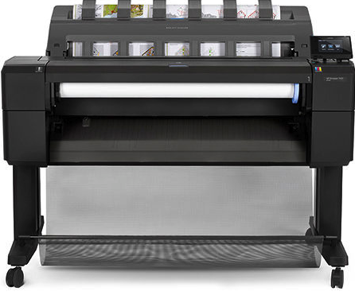

**HP DJ T 920e  36" (A0) Plotter (A3,A2.A1,A0)**  
32 GB Virtual Memory  
50 Sheet output stacker  
Front media loading  
Wide touch screen

01 roll media Input  
Direct USB printing (Flash Drive)  
Network Ready  
Cloud Printing/HP ePrint & Share   
6 Colours 